24th September 2026

Internship Experience Certificate

This is to certify Ms. Rokkala Chandeswari Lakshmidevi (Reg.No: 226N1A05A3), B.Tech (Computer Science and Engineering) student of Srinivasa Institute of Engineering and Technology, Cheyyeru had done an internship at Gradtwin Services, from June 2026 to September 2026 in the Data Science Domain.
We have found her to be a self-starter who is motivated, duty bound and Hard-working. She worked sincerely on her assignments and her performance was Par Excellence.
We are proud to have had Ms. Rokkala Chandeswari Lakshmidevi as part of our team and wish her continued success in her future endeavours. We wish her the best for her future.

For Gradtwin Services (OPC) Private Limited
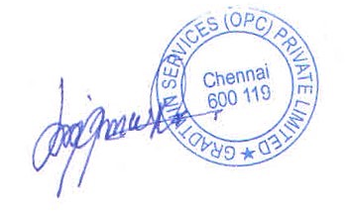

Kanishrajiah Durairaju

Manager - Human Resource

